**Lab task#1:**

#include<bits/stdc++.h>

using namespace std;

int main(){

int n, sum;

cout<<"enter the length of array :";

cin>>n;

int array[n];

for(int i=0;i<n;i++){

cout<<"enter the element "<<(i+1)<<" : ";

cin>>array[i];

}

for(int j=0;j<n;j++){

sum+=array[j];

}

cout<<"The average of array elements is "<<(sum/n);

return 0;

}

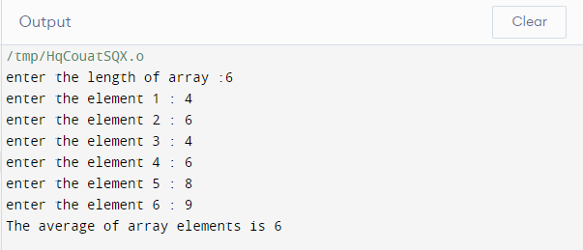

**Lab task#2:**

#include<bits/stdc++.h>

using namespace std;

int main(){

int n;

cout<<"enter the size of array :";

cin>>n;

double array[n];

for(int i=0;i<n;i++){

cout<<"enter the array elements "<<(i+1)<<" : ";

cin>>array[i];

}

cout<<"Real array: "<<endl;

for(int i=0;i<n;i++){

cout<<array[i]<<", ";

}

cout<<endl;

for(int i=0;i<n;i++){

for(int j=0;j<n-i;j++){

if(array[j]>array[j+1]){

int min= array[j];

array[j]=array[j+1];

array[j+1]=min;

}

}

}

cout<<"required array is ";

for(int i=0;i<n;i++){

cout<<array[i]<<", ";

}

return 0;

}

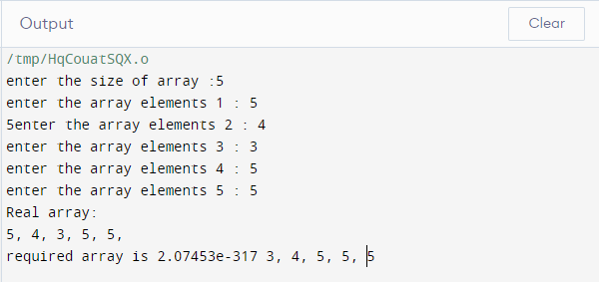

**Lab task#3:**

#include<bits/stdc++.h>

using namespace std;

int main(){

int a;

cout<<"enter the size of array :";

cin>>a;

int array[a],min=0;

for(int k=0;k<a;++k ){

cout<<"enter the array element "<<(k+1)<<" : ";

cin>>array[k];

}

for (int i=0; i<a;i++){

min=array[i];

for(int l=i; l<a; l++){

if(min>array[l]){

min=array[l];

array[l]=array[i];

array[i]=min;

}

}

cout<<array[i]<<" ";

}

}

